Theory Questions

1-Preception:

Perception Sensors:
Lidar: it’s an abbreviation to light detection and ranging which actually explain the working idea the sensor start to emit laser pulses and start to count time when those pulses return back that means an object have got detected.It works by the idea of distance = light speed x time /2 that’s how we can calculate the distance.
The data the sensor gives are mainly 3d coordinates and distance these data forms point cloud which gives a 3d map output.These data sensor collects are processing by main 5 steps:
1.Trajectory post-processing :to refine the position and the orientation of the mapping
2.Point Cloud Generation : by combining the lidar collected data with the post process trajectory
3.Refining point cloud accuracy : by define how much the mutual the mapping overlapping
4.Colorization & Classification: starting to color the map and give labels and this is a table I found clarify this point:
Classification value | Meaning
0 | Created, Never classified
1 | Unassigned
2 | Ground
3 | Low Vegetation
4 | Medium Vegetation
5 | High Vegetation
6 | Building
7 | Low Point
8 | Model Key-Point
9 | Water
10 | Rail
11 | Road Surface
12 | Reserved
13 | Wire - Guard (Shield)
14 | Wire - Conductor (Phase)
15 | Transmission Tower
16 | Wire-Structure Connector (Insulator)
17 | Bridge Deck
18 | High Noise
19 | Reserved
20 | Ignored Ground
21 | Snow
22 | Temporal Exclusion
23–63 | Reserved
64–255 | User Definable
Also lidar used usually for mapping (slam).
Radar: shares similar idea of working but by radio waves , but why to choose radar not lidar?
Because radar is more effective for environmental changes like snow rains which can despite the laser as it’s light for lidar. That’s why autonomous vehicle usually uses the both sensor together.
The radar starts to emit radio frequency (RF) electromagnetic waves toward the environment and when an object detected part of the waves return back to the receiver it measures the time delay happen to detect the distance.
The data got captured is distance , relative velocity, angle and signal strength to be represented as range-Doppler maps , radar point clouds and detected object list.
The data processing starts by 1. Signal filtration 2.Signal filtering 3.Fast Fourier Transform (FFT) for range estimation 3.Doppler processing for velocity estimation 4.Beamforming for angle estimation 5.Target detection 6.Object tracking
Camera: it captures visible light reflected from objects using an optical lens that focuses light onto an image sensor (CCD or CMOS). The sensor converts incoming photons into electrical signals, which are digitized into images. There are Different types include:1. Monocular cameras (single lens) 2.Stereo cameras (two lenses for depth estimation) 3.RGB cameras 4.Infrared (IR) cameras 5.Thermal cameras.
When we use a camera usually the data we got are 2d color images with texture &object appearance like it see with our eyes and can detect the object according to previously trained AI models –machine learning. Which leads as to how the data processing occur 1.Image preprocessing 2. Noise reduction 3.Edge detection 4. Feature extraction 5.Object detection 6.Image segmentation 7.Optical flow estimation 8.Deep learning models (Convolutional Neural Networks (CNNs), YOLO, Faster R-CNN) for object recognition and scene understanding.

Stereo Vision
The idea simply about using two cameras positioned a known distance apart to estimate the 3D position of objects, similar to how human eyes perceive depth.
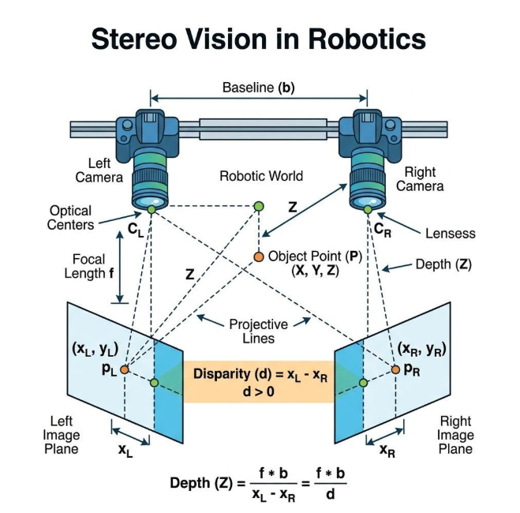
So everything starts with image processing and camera calibration by determining focal length optical Centre and lens distortion then image rectification which are the 2 images lies on the same horizontal lines so the system detect the same object in both images which bring us into calculating the d (difference between the 2 cameras object detection like left one sees it at pixel xl and the right xr) then we can get the depth from here (z) then here we are we have 3d coordinates where X=(x-cx)z/fx same for Y coordinates.

Machine learning
- The neural networks are an advanced machine learning model which is inspired by the biological neurons process information.
The basic neural network consist of 3 main layer input hidden output layer
Where input where the data received the hidden layer is the processing and pattern learning and the output is the result- the classification or prediction.
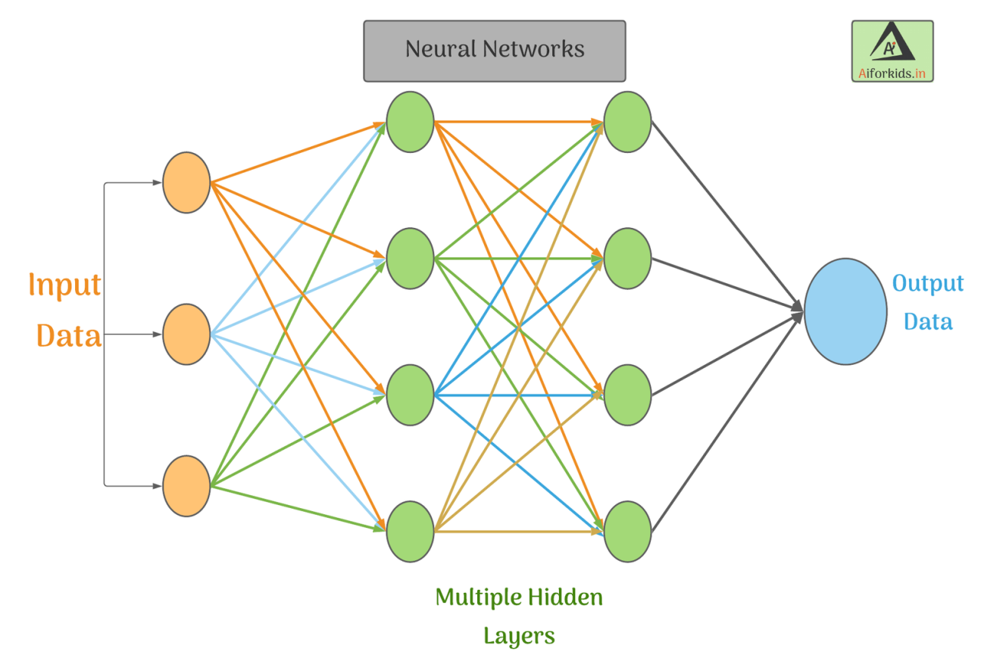
How NNs learn?
Start to learn the model with labeled data – like supervised ml
Then we start to forward propagation we pass the input through the model and calculate the error then back propagation step starts out the network calculates how much weight contributes error then it update the weight with optimization algorithm as gradient descent.
How can neural networks be used to aid with processing sensor data for environment perception?
They are kinda useful for interpret the sensor data as the data collected won’t tell directly to the robot like there’s a car 2m away.
The NNs for Cameras detect the objects with labels as it processes the image into 1. Object detection 2.Object classification 3.Semantic segmentation 4.Lane detection 5.Traffic-sign recognition 6.Pedestrian detection
For lidar it can process the point clouds so it can be used for 1.Object detection 2.Object classification 3.Point-cloud segmentation 4.Ground detection 5.Obstacle detection
Also it helps in Sensor Fusion to combine the information from multiple sensors such as camera lidar and radar where it combines the appearance and classification from the camera the accurate position from 3d position and relative velocity from radar.

State Estimation
- Kalman filter
- Kalman filter is a mathematical algorithm based on bay’s therom that let u to estimate the true state of something like localization of the robot. it based prediction and correction which it get into a loop combining the theoretical data with the sensor data and calculate the kalman gain how much to trust the model or the system from 0 to 1 where 0 refer to the mathematical model dependency and 1 the sensor dependency.
The system built on 2 models motion & sensor models and it start to predict with initial given value according to covariance and start to correct and the covariance changes till the sensor data be reliable enough to be near to the model data
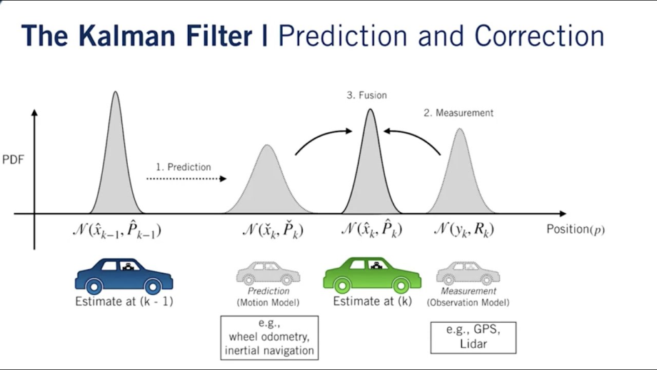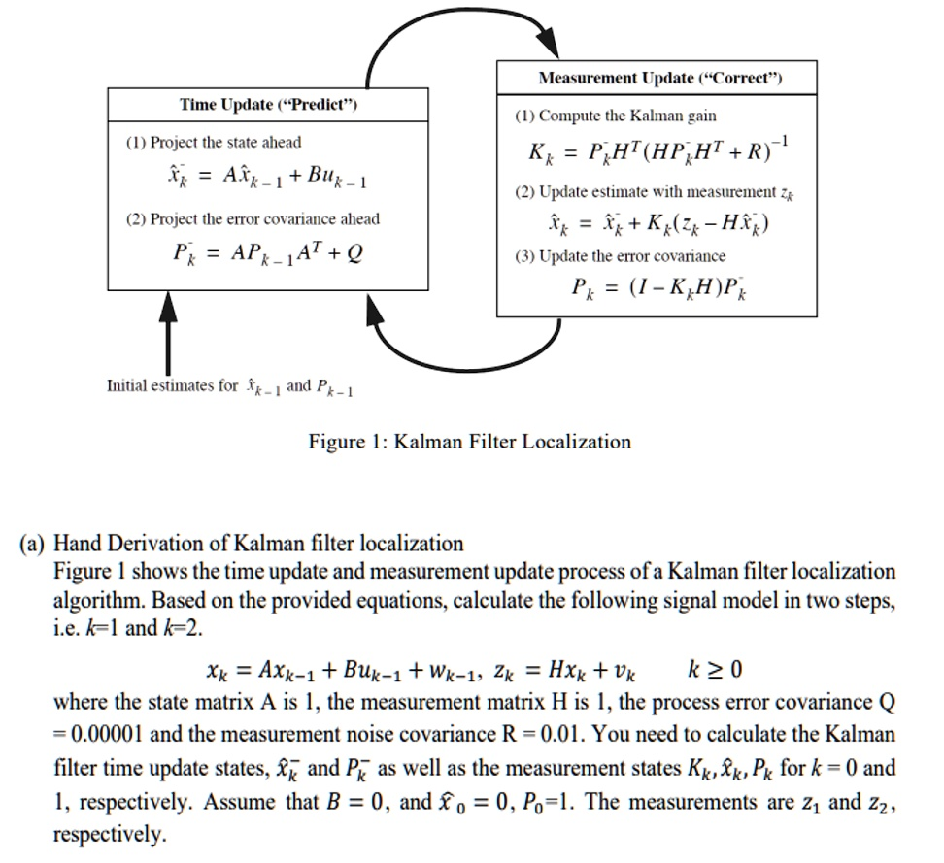
In localization we start to give initial point and the loop provided starts to loop between should it trust the model or the sensor .
- First of all I would use lidar ,camera and imu,start to use slam to get a map then I would estimate the vehicle's x, y, orientation, and velocity. I would use an IMU for predicting the vehicle's motion, while LiDAR and a camera would provide observations of environmental landmarks such as signs, buildings, or road features to correct the predicted position. Radar could also be included to provide distance and relative velocity measurements, especially in poor weather. The Kalman filter would fuse these measurements to obtain a more accurate estimate of the vehicle's position and orientation.

Slam
It’s abbreviation of Simultaneous Localization and Mapping refers to creating a map of unknown environment while simultaneous localize and estimate the position of the vehicle inside the map ,Slam mainly goes through this loop
Sensors → Perception → Localization & Mapping → Updated Pose + Map → Motion → Sensors
Common types of SLAM include:
- LiDAR SLAM: Uses laser scans to detect walls and obstacles.
- Visual SLAM (V-SLAM): Uses cameras to extract and track visual features.
- Visual-Inertial SLAM: Combines cameras with an IMU.
- RGB-D SLAM: Uses an RGB-D camera to obtain both color and depth.
- Radar SLAM: Uses radar measurements, useful in poor visibility conditions.
From the algorithm side, SLAM can also be implemented using methods such as EKF-SLAM, Graph-based SLAM, FastSLAM, and particle-filter-based SLAM

How to build a map?
First of all we need collection of sensors like encoder lidar imu and camera then we start to move the robot/vehicle inside the the environment to detect and sensing landmarks like walls signs ect. And update and match the current observation with the previous observed ones and estimate the position of the robot (x,y,theta) update the observed into a map like occupancy map which white pixels refers to free space black for obstacles and grey for unknown like what behind the wall and areas the robot didn’t map yet.
How does SLAM perform vehicle localization in an unknown environment? Discuss in two different types of SLAM?
SLAM localizes a vehicle in an unknown environment by combining motion information from sensors such as wheel encoders or IMU with observations from LiDAR or cameras. It simultaneously estimates the vehicle's pose and builds a map of the environment. In EKF-SLAM, the vehicle pose and landmarks are estimated using an Extended Kalman Filter through prediction and correction steps. In FastSLAM, a particle filter represents multiple possible vehicle poses, weights them according to sensor observations, and resamples the most likely poses while constructing the map.

Motion planning

Graph Search Algorithms
First of all graph is a type of data structure which contains vertices (nodes) and edges this type of data structure is almost present everything and anything like cities workstation ect
Path planning start with graph searching which most of algorthims built based on

BFS – Breadth-First Search & DFS Depth-First Search
BFS explores the graph level by level. It starts from the initial node, visits all its immediate neighbors, then all neighbors of those nodes, and so on. It uses a queue.
Pros | - Simple to implement.  - Finds the shortest path in terms of number of edges when all edges have equal cost.  - Complete: it will find a solution if one exists.
Cons | - Can require a large amount of memory.  - Becomes inefficient for large search spaces.  - Does not consider the actual cost of edges if they have different weights
DFS explores as deeply as possible along one branch before backtracking and trying another branch. It uses a stack .
Pros | - Simple to implement.  - Requires less memory than BFS in many cases.  - Useful when the solution may be deep in the search tree.
Cons | - Does not guarantee the shortest path.  - Can spend a long time exploring an unpromising branch.  - Can get stuck going very deep without finding a good solution unless visited-node handling is used

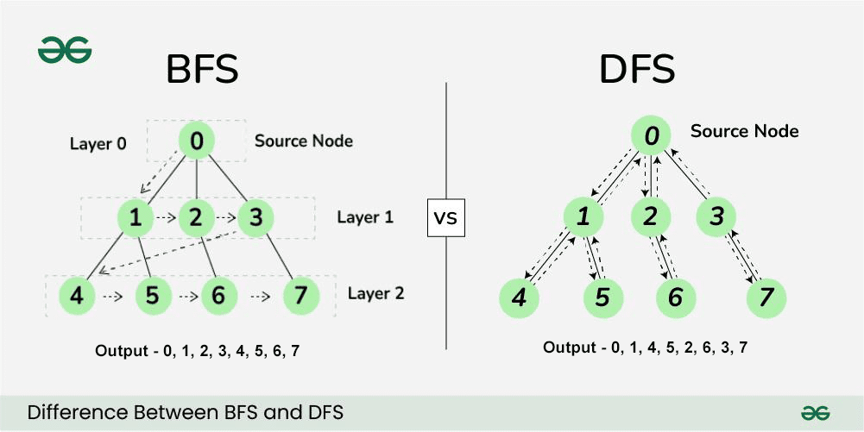

Dijkstra’s Algorithm
Dijkstra finds the minimum-cost path from a starting node to other nodes.It assigns a cost to each node representing the cheapest known distance from the start. It repeatedly selects the node with the lowest current cost and updates its neighbors. Unlike BFS, Dijkstra can handle different edge costs
Pros: | - Finds the optimal/shortest path when edge costs are non-negative.  - Works with weighted graphs.  - Useful when the cost of moving between nodes is different
Cons: | - Can explore many unnecessary nodes.  - Usually slower than A* when a good heuristic is available.  - Can require significant memory for large graphs
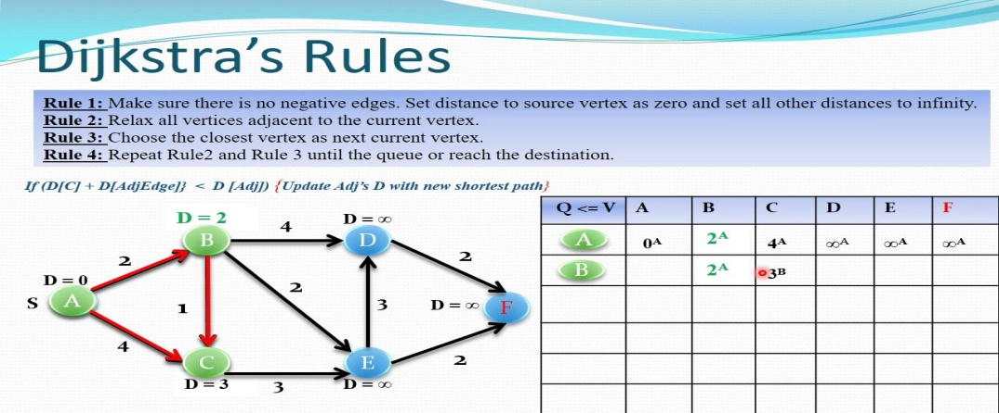

A* Algorithim
A* combines the ideas of Dijkstra's algorithm and heuristic search A* prioritizes the node with the lowest f(n) where f(n)=g(n)+h(n)And
- g(n) = actual cost from the start node to node n
- h(n) = estimated cost from n to the goal
- f(n) = estimated total cost of the path through n
Pros | - Usually much faster than Dijkstra because it searches toward the goal.  - Can find the optimal path if the heuristic is admissible/does not overestimate the remaining cost.  - Very widely used in robot and game path planning
Cons | - Requires a suitable heuristic.  - Can still require significant memory.  - Performance depends strongly on the quality of the heuristic

Practical Motion Planning

Solution
Apply a path smoothing algorithm after A* to reduce the sharp turns and unnecessary zig-zag movements in the generated path. Methods such as Bezier curves, splines, or shortcut smoothing can be used. A PID controller can then be used to make the robot accurately follow the smoothed path.
Pipeline:
A* → Path Smoothing → PID Controller → Robot

Risk
The main risk is that smoothing may change the original collision-free path. The new path could pass too close to or even collide with obstacles.
Therefore, the smoothed path should be checked against the map for collision and sufficient safety clearance before execution.
- Control
- Control theory
Control is the process of making a system behave in a desired way by manipulating its inputs.
Control Theory is the branch of engineering and mathematics concerned with analyzing and designing systems that automatically regulate their behavior to achieve a desired output.
A basic control system consists of:
Desired value (Reference) → Controller → Plant/System → Output
Control theory is important because it allows engineers to:
- Improve accuracy and performance.
- Maintain system stability.
- Reduce errors and disturbances.
- Make systems respond faster and more reliably.
- Automate processes without continuous human intervention.

For Real-world applications Control systems are used in many engineering fields: Automotive , Robotics , Industrial Automations and Aerospaces applications too
The main difference between open-loop and closed-loop control is the use of feedback. In an open-loop system, the controller generates an input without measuring the output to correct the system's behavior. Therefore, it cannot automatically compensate for errors or disturbances. In a closed-loop system, the output is measured using sensors and fed back to the controller. The controller compares the actual output with the desired output and adjusts the control action according to the error.
For example, an autonomous vehicle requires closed-loop control because it continuously receives feedback from sensors and state estimation about its position, velocity, and orientation. The controller compares the estimated state with the desired state and adjusts the steering, throttle, or braking accordingly. 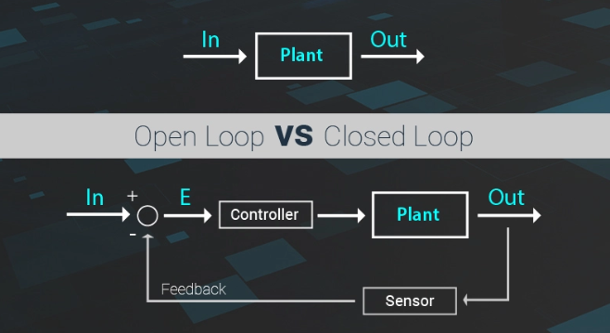
- PID
A PID controller is a feedback controller that adjusts the system's input to make the actual output reach the desired value.
It has three parts:
- P – Proportional: Depends on the current error. The bigger the error, the bigger the control action.
- I – Integral: Depends on the accumulated error over time. It helps remove the remaining or steady-state error.
- D – Derivative: Depends on how fast the error is changing. It helps reduce overshoot and makes the system more stable and smooth.
The PID equation is:
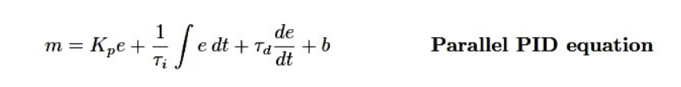
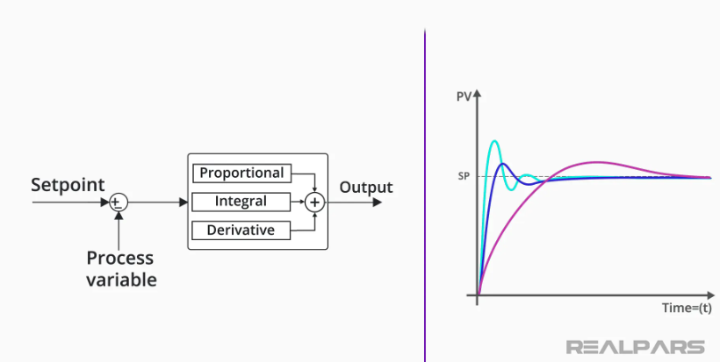
For example, in a robot motor, PID can continuously compare the desired speed with the actual speed and adjust the motor power to reach and maintain the desired speed

Effect of Each PID Component
- P (Proportional): Increases the response speed. A higher KP​ reduces the error, but too much can cause overshoot and oscillation.
- I (Integral): Removes steady-state error. Too much KI​ can cause overshoot and slow oscillations.
- D (Derivative): Reduces overshoot and oscillations and improves stability. Too much KD​ can make the system sensitive to noise.

How to Tune a PID Controller
PID tuning means finding suitable values for KP​, KI​, and KD​ to get the desired system response.

1. Ziegler-Nichols Method
A common experimental method:
- Set I and D to zero.
- Increase KP​ until the system reaches continuous oscillation.
- Record the critical gain Ku​ and oscillation period Tu​.
- Use these values to calculate KP​, KI​, and KD​ using Ziegler-Nichols tuning rules.
Pros: Simple and systematic.
Cons: Can produce significant overshoot and may not be suitable for sensitive systems.

2. Manual / Trial-and-Error Tuning – which I do usually
Adjust the gains gradually while observing the system response:
- Increase KP​ until the response is fast but does not oscillate excessively.
- Increase KI​ until the steady-state error is removed.
- Increase KD​ to reduce overshoot and improve stability.
Pros: Simple and practical.
Cons: Takes time and depends on the engineer's experience.
How would I implement a PID controller for this application?
For an industrial furnace, I would use a PID controller to control the heater and maintain the desired temperature.
- Set the desired temperature, for example 800°C.
- A thermocouple measures the actual furnace temperature.
- The controller calculates the error between desired and actual temperature.
- The PID uses this error to control the heater power.
- The sensor continuously measures the temperature and sends feedback to the controller
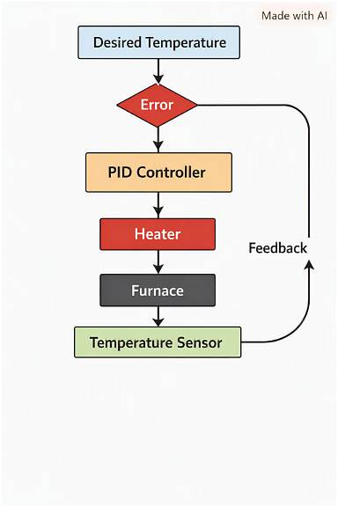

Limitations of PID Controllers
PID controllers are simple and widely used, but they have some limitations:
- Difficult to tune for complex systems.
- Can have overshoot and oscillations if not tuned properly.
- The derivative part is sensitive to sensor noise.
- They may perform poorly with nonlinear or highly changing systems.
- They do not handle multiple inputs and outputs very well.
- They usually do not predict future system behavior.

When should we use other controllers?
Other controllers can be better when the system is complex or has special requirements:
- Model Predictive Control (MPC): Good for complex systems with multiple inputs/outputs and constraints, such as autonomous vehicles.
- Fuzzy Logic Control: Useful when the system is difficult to model mathematically.
- Adaptive Control: Useful when the system parameters change over time.
- LQR: Useful when we have a mathematical model and want to optimize system performance

Finally, thank you for such an opportunity to research and learn more it was very valuable I would like to represent my ideas and understanding in much better way but unfortunately I was little bit in rush but I’m excited to discuss all the theories in the interview soon inshallah!

